

**The Fibonacci sequence: A brief introduction**

[**by Rachel Thomas**](http://plus.maths.org/content/list-by-author/Rachel%20Thomas)



Leonardo Fibonacci c1175-1250.

The Fibonacci sequence

|  |  |  |  |
| --- | --- | --- | --- |
|  | \[ 1, 1, 2, 3, 5, 8, 13, 21, 34, 55, 89, ... \] |  |  |

is one of the most famous number sequences of them all. We’ve given you the first few numbers here, but what’s the next one in line? It turns out that the answer is simple. Every number in the Fibonacci sequence (starting from $2$) is the sum of the two numbers preceding it:

|  |  |  |  |  |  |  |  |
| --- | --- | --- | --- | --- | --- | --- | --- |
|  | $\displaystyle 2  $ | $\displaystyle  =  $ | $\displaystyle  1  $ | $\displaystyle + $ | $\displaystyle  1  $ |  |  |
|  | $\displaystyle 3  $ | $\displaystyle  =  $ | $\displaystyle  1  $ | $\displaystyle + $ | $\displaystyle  2  $ |  |  |
|  | $\displaystyle 5  $ | $\displaystyle  =  $ | $\displaystyle  2  $ | $\displaystyle + $ | $\displaystyle  3 $ |  |  |
|  | $\displaystyle 8  $ | $\displaystyle  =  $ | $\displaystyle  3  $ | $\displaystyle + $ | $\displaystyle  5,  $ |  |  |

and so on. So it’s pretty easy to figure out that the next number in the sequence above is $55+89 = 144,$ and (in theory at least) to work out all numbers that follow from here to infinity.

**Where does it come from?**

The Fibonacci sequence was discovered back in the 13th century, when a mathematician by the name of [Leonardo Fibonacci](http://plus.maths.org/content/life-and-numbers-fibonacci) engaged in a curious thought experiment. Fibonacci started with a pair of fictional and slightly unbelievable baby rabbits, a baby boy rabbit and a baby girl rabbit.



They were fully grown after one month



and did what rabbits do best, so that the next month two more baby rabbits (again a boy and a girl) were born.



The next month these babies were fully grown and the first pair had two more baby rabbits (again, handily a boy and a girl).

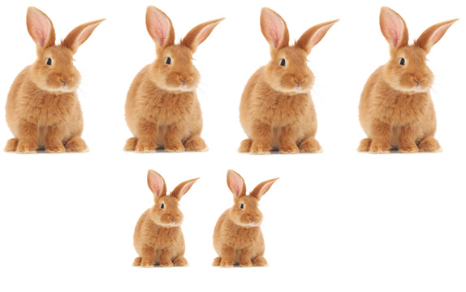

Ignoring problems of in-breeding, the next month the two adult pairs each have a pair of baby rabbits and the babies from last month mature.

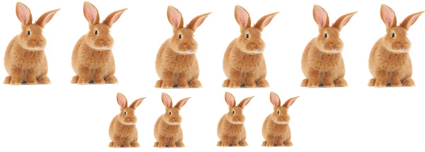

Fibonacci asked how many rabbits a single pair can produce after a year with this highly unbelievable breeding process (rabbits never die, every month each adult pair produces a mixed pair of baby rabbits who mature the next month). He realised that the number of adult pairs in a given month is the total number of rabbits (both adults and babies) in the previous month. Writing $A_ n$ for the number of adult pairs in the $nth$ month and $R_ n$ for the total number of pairs in the $nth$ month, this gives

|  |  |  |  |
| --- | --- | --- | --- |
|  | \[ A_ n = R_{n-1}. \] |  |  |

Fibonacci also realised that the number of baby pairs in a given month is the number of adult pairs in the previous month. Writing $B_ n$ for the number of baby pairs in the $nth$ month, this gives

|  |  |  |  |
| --- | --- | --- | --- |
|  | \[ B_ n = A_{n-1} = R_{n-2}. \] |  |  |

Therefore, the total number of pairs of rabbits (adult+baby) in a particular month is the sum of the total pairs of rabbits in the previous two months:

|  |  |  |  |
| --- | --- | --- | --- |
|  | \[ R_ n = A_ n + B_ n = R_{n-1}+R_{n-2}. \] |  |  |

Starting with one pair, the sequence we generate is exactly the sequence at the start of this article. And from that we can see that after twelve months there will be $144$ pairs of rabbits.

**Where does it go?**

Real rabbits don't breed as Fibonacci hypothesised, but his sequence still appears frequently in nature, as it seems to capture some aspect of growth. You can find it, for example, in the turns of natural spirals, in plants, and in the family tree of bees. The sequence is also closely related to a famous number called the *golden ratio*. To find out more read [*The life and numbers of Fibonacci*](http://plus.maths.org/content/life-and-numbers-fibonacci).